**Insights from the Dashboard:**

**For KPIs: There are some insights from the KPIs which are based on some conditions are as follows:**

1. Total number of Shows including (TV Shows/Series & Movies)
2. Total number of “movies only”
3. Total number of “TV Shows/Series only”
4. Total number of “Adult Movies” which is based on Rating “Restricted”
5. Total number of “Child and Family Movies”
6. Total number of “Mature Audiences”
7. How many movies and TV Shows are normal for General Audiences, All Audiences and All Children.
8. Highest duration and Lowest duration overall shows.
9. Total Contents are adding year by year.

**Map: It is showing Top 10 Countries on the basis of Ratings and Shows**

1. Total Shows including Movies and TV Shows/Series
2. For each Country
3. Shows the count on the basis of Ratings
4. It will show the count of Movies and TV Shows/Series

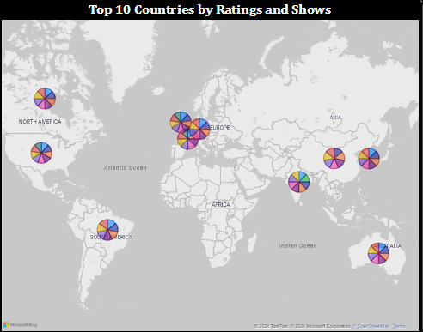

**Donut-Chart: It will show the share of total movies and tv shows**

1. It will show the sharing percentage of Movies and TV Shows/Series.

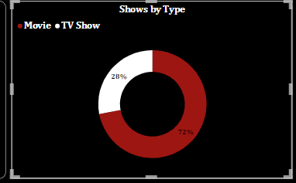

**Area Chart:**  **It will show the total counts of Movies and TV Shows/Series.**

1. It is showing the Trend of the Movies and TV Shows that how much they are increasing and decreasing year by year and also for each country.

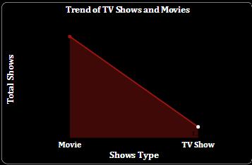

**Line and Clustered Column Chart: It will show the percentage of contents and total count of shows are adding year by year.**

1. It will show the contents adding percentage year by year.
2. It will show the counts of shows are adding year by year from 2008 till present.
3. It will also show the Trend of Movies and TV Shows for each Year.
4. In this visual I have created a “Drill Through” option as well as it will show us the detail level of information like (Total No of Shows, Years, Categories Name and Tittle Name).

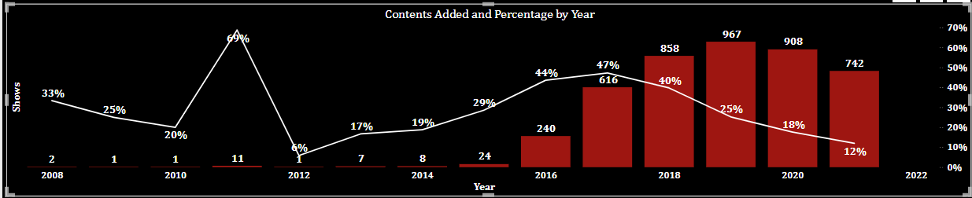

**Line and Stack Column Chart: It will show the data for country and directors**

1. The columns will show the data of Shows on the basis of Total categories for each Country.
2. Line will show the total directors for each country.

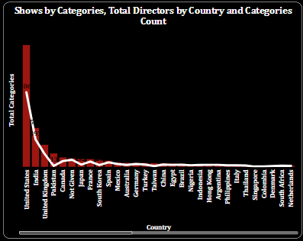

**Stacked Bar Chart: It will show the data for all shows on the basis of Ratings**

1. Bars will present the total count of Shows for each Country on the basis of Ratings.
2. It will give the information about how many shows which are adding on Netflix in each country on the basis of given Ratings.
3. Ratings will like for Mature Audiences, Restricted Shows, Shows for Children and Families etc.

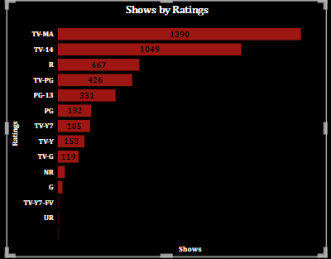

**Stacked Bar Chart:**  **It will show the data for each country.**

1. It will show the total count of Shows for each country.
2. It will also give the insights that which country provided the greatest number of contents
3. It will help Netflix to do the analysis for the specific country.

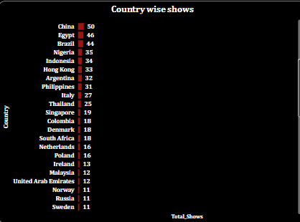

**Table: Table is providing the detail level of Information of the dataset**

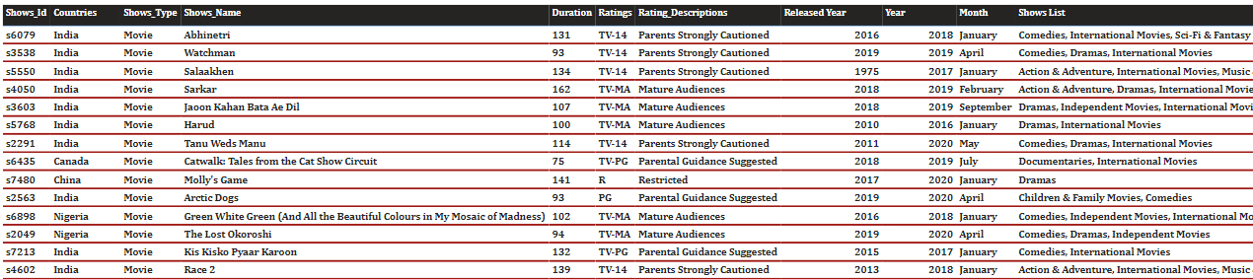

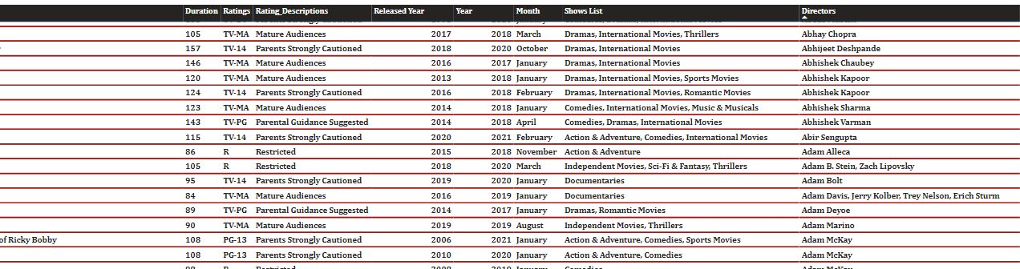

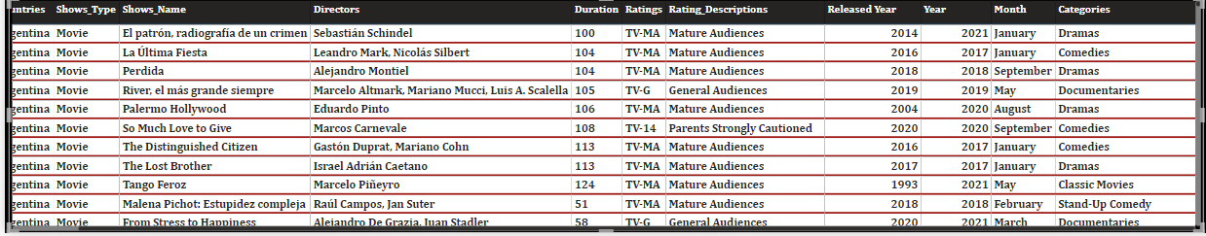

**Detail Information Page for Drill Through:**

